
Technological Institute of the Philippines
938 Aurora Boulevard Cubao, Quezon City

ITE 010 – INTRODUCTION TO HUMAN-COMPUTER INTERACTION
Assignment 1.2 – Examples of Good and Bad Designs

Name: Aristotle Buenaventura
Section: IT12S1

Good Designs



I do not even understand the characters in this post but I can still understand the meaning of the post. It is clearly stated on the diagram that dog pooping is not allowed. This is a good design

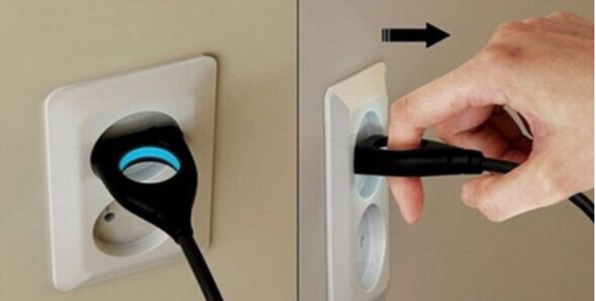

It is really hard for us to unplug our devices especially if our hands are wet but with this kind of design, it is easy to pull the plug. It will also lessen the worry that you will electrocute by pulling the plug.

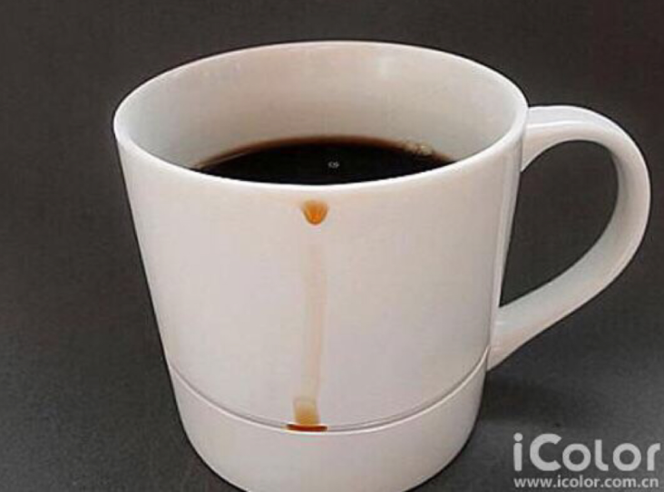

When we want to drink coffee，cola，sprite，hot tea, etc. Sometimes, the liquid will slide following the cup margin. But this cup can collect this liquid by cup gap.

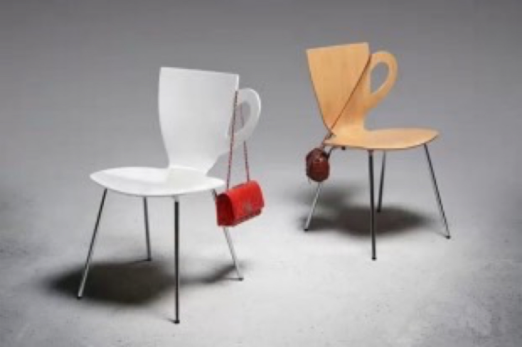

These chairs are different from other chairs，it has added a thing which can hang on the bags.

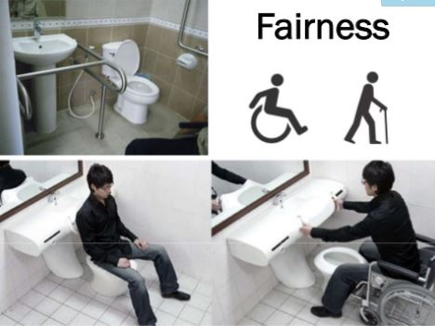

Only two things are really important when you want to create a functional bathroom for a disabled person. Make the bathroom design safe for someone with mobility problems and ensure that using it safe and comfortable.
Maneuvering alone in the bathroom is very dangerous for someone who has difficulties with movement. Falling on the floor are common accidents that can occur to a disabled. Properly designed bathrooms greatly help people to stay more independent and experience safe, functional, and comfortable modern bathroom design.

Bad Designs

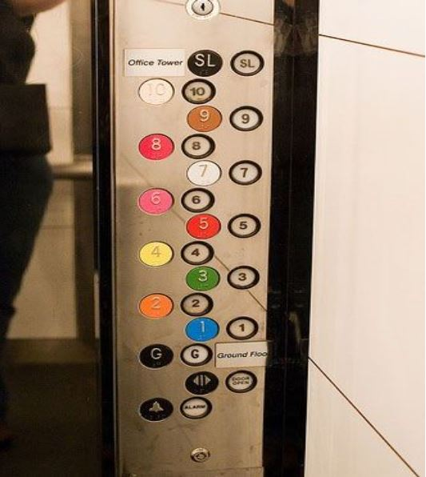

Elevator controls and labels are confusing, so it is easy to push a label by mistake instead of a control button.

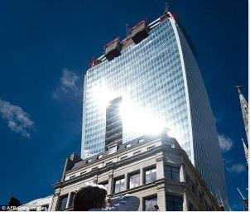

The Walkie-Talkie skyscraper in London is rather beautiful, but it has a little problem. The concave design concentrates sunlight on the street below, effectively cooking everything in sight.
The concentrated light is so hot that residents have taken to cooking meals on the street. Yes, it’s that hot. How does that work, exactly? During a certain window of time, the sun is angled such that the concave shape of the building reflects and concentrates the light to a narrow region on the street below.

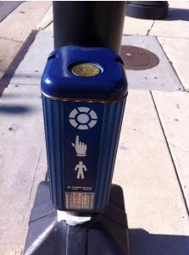

Most of us would be likely to tap the metal circle on top to initiate the walk sign. Right? I mean, the diagram shows a picture of a finger tapping a circle. Or is that a diagram? No, the metal circle on top does nothing. The white circle is not part of the diagram – it’s the button. Though it looks like it has printed on there.

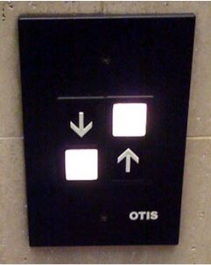

The designers figured that the barely perceptible line between the two buttons was a big enough clue for all of us. Even putting those with poor eyesight aside, it’s pretty easy to imagine how many people stood there in confusion before inadvertently taking themselves to the basement.

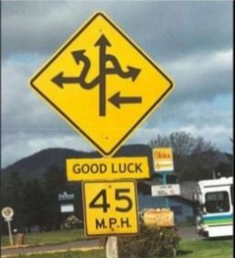

This sign is so confusing it could cause accidents. Imagine driving past this and trying to make sense of it. A stop sign may have been more effective.

